# **Branching Strategy**

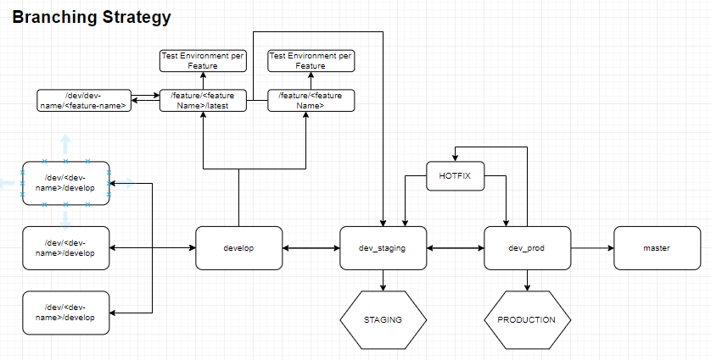

1. /dev/<dev name>/develop.

* Branch for each developer to do their work.
* Each day developers must pull from develop branch before starting work. 09 AM, 12 PM, 6 PM

2. develop

* The latest branch contains merged code from all dev participants.
* Merge to this branch will be done by PIC

3. dev_staging

* Code from develop will be built on the Staging environment.
* Merge to this branch will be done by PIC

4. dev_production

* Code from dev staging - development free, build for the production environment.
* Merge to this branch Must be approved by PM or Management In Charge

5. Master

* The most stable code, act as a source code.version will always - 1 from the develop.
* Merge to this branch Must be approved by PM or Management In Charge
* Merge to this branch must be done before merging staging in to develop

6. /feature/<featureName>/Latest

* If the project developed per feature then we have a specific branch for each feature. This branch will be deleted once the code merged to staging and deployed on production.
* The developer will be developing on each of his branches: dev/<devName>/featureDevelop.
* Each day developer must pull from feature’s specific branch before start work. 09 AM, 12 PPM,6 PM

7. Hotfix

* Branch for hot fixing, branch out directly from dev_production than once done merged into dev_staging and dev_prod.
* Can only create this branch on approval of management in charge

------------------------------------------------------------

## IMPORTANT NOTES

1. Each push must use PR (Pull Request) to “develop” Branch.
2. Build and push staging occurs at :
   1. 12 PM WITA
   2. 17 PM WITA
3. Format of PR
   1. Title : PR <nameOfDev> - <DD MMM YYYY> - <HH:MM>
   2. Description :
      1. List of change : <jiraTaskLink> - Summary
   3. Always set branch to develop unless requested by PM

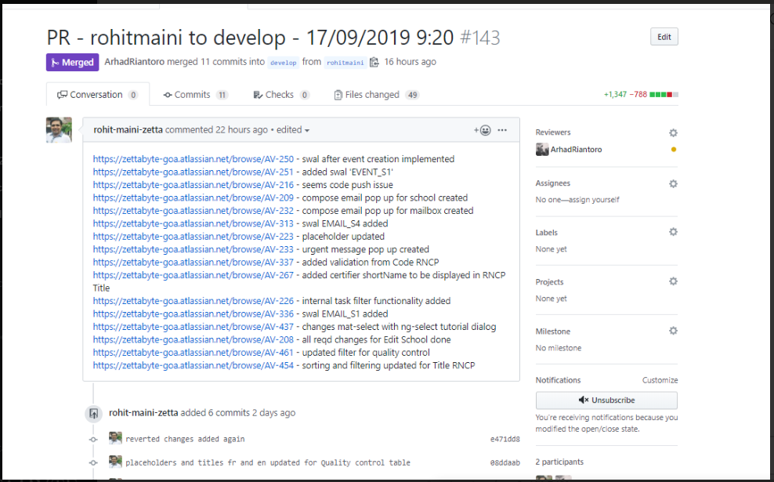

## **EDH PRE-PRODUCTION BRANCHING**

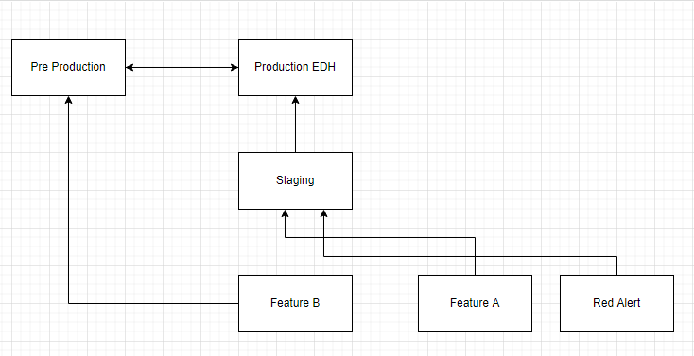

On EDH we have an environment named Pre Production which is used by the Customer before the features go live in Production. To handle this, we need to do separate thing :

1. Always Need to be Done :
   1. Update Pre Production Branch with Production EDH Branch everytime EDH Production is pushed to make sure Pre Production EDH is always up to date
2. For Features that needed to be tested by Customer before pushing to Production
   1. **QA Testing** : Create PR from Features Branch to Staging Branch
   2. **Customer Testing** : After QA Testing in Staging & Pass, or When Customers want to test the features by themselves, then we need to Create PR from Features Branch to Pre Production Branch.
   3. **Production Push :** Create PR from Feature Branch to Staging Branch and update EDH Production Branch with Staging Branch.
3. For Features that does not need to be tested by Customer before pushing to Production
   1. **QA Testing** : Create PR from Features Branch to Staging Branch
   2. **Production Push** : Create PR from Feature Branch to Staging Branch and update EDH Production Branch with Staging Branch

These are the names of branches in EDH :

1. **Production** : project_edh_production
2. **Pre Production** : project_edh_pre_production
3. **Staging** : project_edh_staging